The ultimate guide to logo design: 30 expert tips

Follow these pro tips and create your best ever logo design. Paul Wyatt reveals everything you need to know to improve your designs.
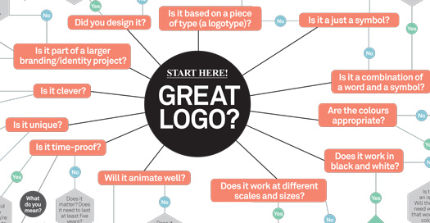
Words: Paul Wyatt
Logos are all around us. To the general public they serve as an instant reminder of a company or a product; to the client they’re the point of recognition on which their brand hangs; and to us designers they represent the challenge of incorporating our clients’ ideologies into one single graphic.
No wonder, then, that they feature so prominently in our lives. In an age where everyone must have a website to support their product, service or the company behind it, the demand for logo design has never been higher.
More logos are out there than ever before, and with that comes the challenge of being different. How do we create something original that stands out in a sea of identities? And how do we create something quickly while retaining quality?
In this article, we'll first look at the basic principles of creating a logo and share some pro tips for finessing your process and design...

01. Research your audience
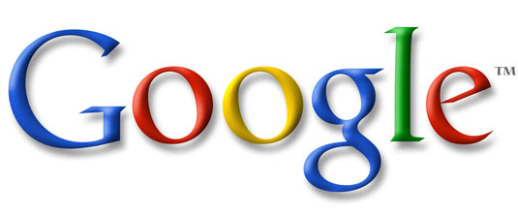A logo isn't just something that looks nice - it has to communicate a brand message
Designing a logo isn’t just about creating a pretty visual. What you’re doing, or taking part in, is developing a brand and communicating a position. It makes sense, then, that the first step in creating a logo should not be about design but about research into these concepts.
Involving the client at this early stage is advised, as your interpretation of their brand may be different from theirs, and it’s essential that the message is clear before any actual designing takes place.

02. Immerse yourself in the brand
Before even beginning to sketch out ideas for a logo, spend some time compiling the equivalent of an M15 dossier on your client's brand: who they are, what they do and what their demographic is.
Look at previous iterations of their logo and ask yourself what doesn't represent the brand on these. Then compile a 'dos and don'ts' checklist before your creative work starts.

03. Online research
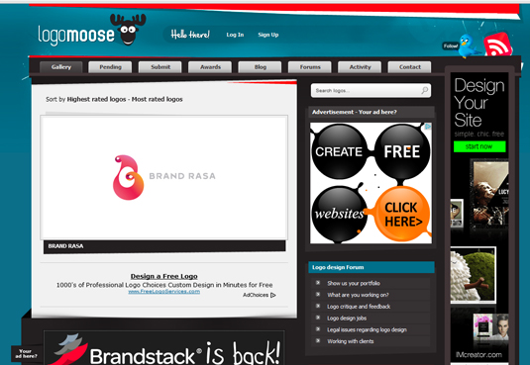Logo Moose is a great research resource
Two great starting points for online logo design research are Logo Moose and Logo Gala. One thing to be mindful of is knowing when to stop your logo research. It's best to look at what did and didn't work out of 10 relevant logos than swamp yourself with 50 extraneous ones.

04. Don't let clients dictate
Point 2 does not mean you should just do what the client tells you. Look through the brief from your client and begin to ask questions about any vagueness or lazy brief writing you might find there. 'The logo should be iconic' and 'The logo should be memorable' are two extremely clichéd phrases you need to pull your client up about.
A man kicking a chicken dressed as Father Christmas is memorable but for the wrong reasons. So, as with all commissioned design work, you need to manage your client's expectations, set realistic goals and find out what exactly your work needs to convey. Logos become iconic and memorable: they're not created that way.

05. Sketch it out
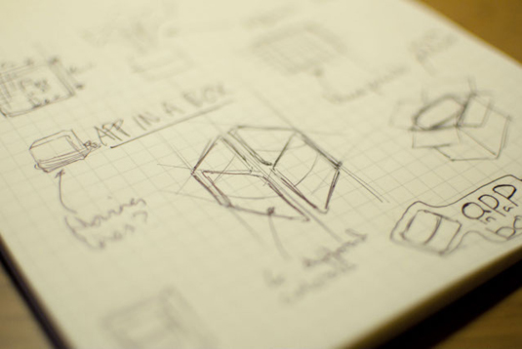Get the pencil and pad out before switching on your computer. Picture credit: Ben Powell at www.gogetcreative.co.uk
With a solid understanding of what needs to be communicated, it’s on to the first sketches: more often than not, these should be the pen and paper kind. This enables you to be experimental and not get caught up in the finer details.
It's tempting to move straight onto the computer first, but Ben Powell advises you resist the urge. "What did you learn to do first, use a computer or a pencil and paper?" he asks rhetorically. "Sketching is a much faster way to produce initial ideas before you even touch Photoshop. It doesn't matter if it's complete chicken-scratch sketching as long as it conveys your ideas correctly and you understand it."

06. Seek inspiration
If you’re struggling for ideas, try looking up key words in a dictionary or thesaurus or searching Google images for inspiration. If you keep a sketch book then look at previous drawings – you’re bound to have unused ideas from previous projects, so you may already be sitting on the perfect solution.

07. Create vectors
Vectors are a good 'in-between' stage of logo creation. Picture credit: Ben Powell at www.gogetcreative.co.uk
After starting with a sketch, some designers then progress to more technical sketches on graph paper. But the best way to save any pain and frustration with later iterations of your logo design is to produce it using vectors. Here Illustrator CS6 is your friend as you'll be able to rescale your creation without losing any quality. You can copy and paste your logo into Photoshop as a 'smart object' (again with no loss of scalable quality), if you need to combine it with other elements.
If you're designing a logo for screenbased media, be particularly careful of thin lines or very light typefaces. Also consider that different monitors can make text and graphics appear pixelated or rough.

08. Choose your typeface
Microsoft's new logo represents a trend towards clear and functional typography in logos
Typography is obviously central to good logo design. You have two main routes to choose from: creating your own custom typeface or adapting an existing one.
If you create a custom typeface, try not to make it too fashionable because it could date quickly. Keep it simple and legible. Consider the words that you’re depicting – if they’re unusual then a simple typeface might work best; if they’re common words then you can usually be more creative as they’re easier to recognise.

Adapting an existing typeface
There's no rule to say you have to create your own typeface, though: consider adapting an existing one.
Removing, extending or joining parts of letters may be enough to make your design unique. It’s amazing how little you need to see of some letters for you to still be able to recognise them.

09. Avoid gimmicky fonts
Don't be tempted to make your logo stand out by using gimmicky fonts. They're the equivalent of typographic chintz and there's a reason why most of them are free. For sheer professionalism's sake you should avoid them at all costs.
Most gimmicky fonts are too fancy, too weak, and are most likely being used (badly) on a hundred different cheap business cards right now. When it comes to logo design, keep your font choices classic and simple and avoid over-garnishing your logo.

10. The name CAN be the logo
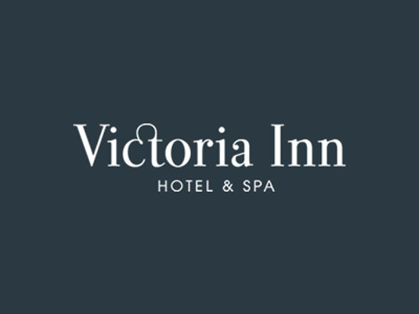Stylised typeface forms Victoria Inn's logo. Picture credit: Ben Powell at www.gogetcreative.co.uk
You may want to produce a simple execution of a logo for your client that uses the strength of the typography alone as the logo.
Fonts come in all shapes and sizes that resonate differently with strength (slab type fonts, big and powerful); class and style (fonts with elegant scripts or serifs); movement and forward thinking (type that is slanted). Provided the qualities of the font - be it bespoke or off-the-shelf - match the qualities of the brand, you're onto a winner.
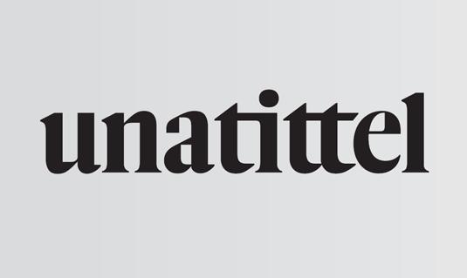A strong bespoke type treatment for the Unatittel Art Collective by Luke Prowse

11. Consider tones as well as colours
Logos need to work in black and white as well as colour. If your logo design uses colour to convey meaning, think about how you can reflect that meaning when the colour is removed from the logo. Sometimes this may mean changing the contrast relationship between different elements of your design so that they still convey meaning when reproduced in monotones.

12. Design for specific usage scenarios
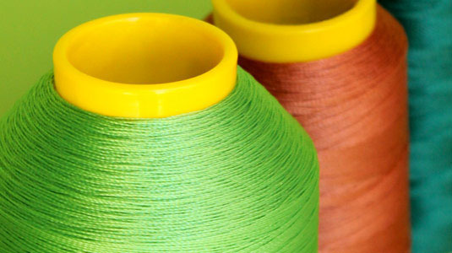Your logo design may need to be altered to work on different media, such as being reproduced in cotton embroidery
As mentioned earlier, logos have to be reproduced across all sorts of different media, including print, web, embroidery and billboards. If you’ve opted for an intricate design that works well at a large size, you may need to simplify it for smaller or difficult reproduction. It’s quite common to have a slightly different version of a logo for reproduction on clothing for example. The best way to get this right is to talk to an embroiderer (or sign-maker, shoe-manufacturer etc as appropriate)

13. Think about the space around your logo
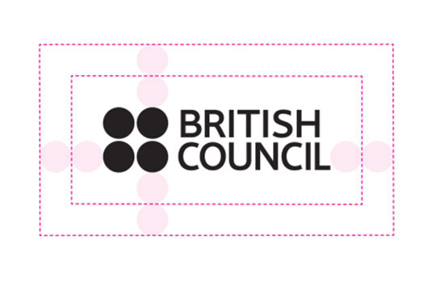The British Council has an exclusion zone based on the discs that make up part of its design
Most brand books will specify an exclusion zone. This is an area around the logo that can’t be occupied by other content, to protect the integrity of the logo (and brand by extension). When you’re designing a logo, you need to consider how it should be used. If, for example, your design is intended to be viewed over the top of a photographic image, make sure you present it to the client in that way, and specify that it should be reproduced in this manner each time it’s used.

14. Use negative space effectively
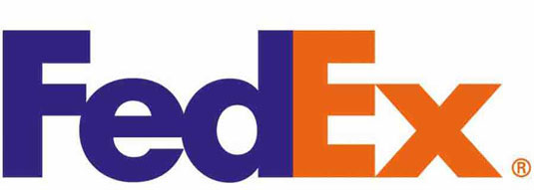The FedEx logo is a well-cited example of effective use of negative space in logo design
Some of the best logos have hidden meaning in their negative space. A classic example is the Fed Ex logo which uses the combination of the letters E and x to form an arrow in the negative space. There are many other great examples where a logo looks ordinary at first glance, but reveals interesting and well-thought-out details on further examination. Try to use this principle to add value to your logo design, but don’t add shapes and pictorial elements in negative space just because you can!

15. Make your design active, not passive
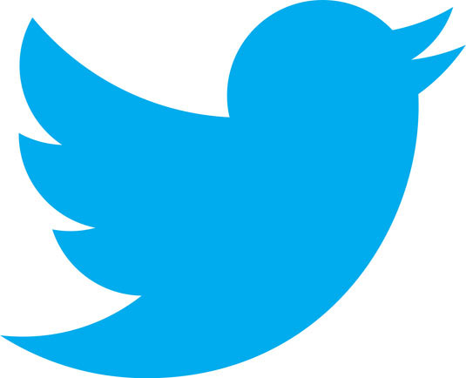The twitter logo has morphed from a static bird into one in flightover the years, suggesting motion and movement
If you’re using a device within your logo that facilitates it, consider adding a sense of movement to your design. This doesn’t mean you need to add cartoon-like motion lines, but rather think about the size, position and rotation of elements within your design.
A fish will look in motion if it’s mid jump or swim, but will look static if drawn side on as if it’s been mounted on a wall. You also need to take into account the direction of the implied motion.
In the west, motion towards the left of the stage suggests backwards, regressive movement, while motion towards the right feels progressive and forward-thinking. This culture-based understanding is formed because we read from left to right. Things are different in the far East, so make sure you understand where your principal market is.

16. Create suitable variants
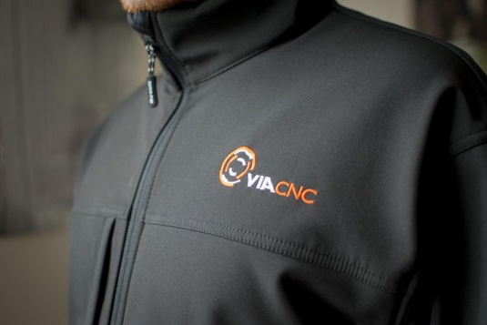Logos have to be consistent for all manner of different applications. Picture credit: Ben Powell at www.gogetcreative.co.uk
Your logo is amazing, beautiful, and stunning... but only on your 24in full HD monitor. Shrink that baby down to 100 pixels and what have you got? A little undecipherable splodge.
Experiment with your designs at different sizes. If you’ve already got
them on your computer, zoom in and out to see if they work as tiny icons or when they’re full screen.

Make it legible
Most clients need a vector version of the logo in order to be able to scale it up, cut it out and colour separate it. Equally, you need something that will be legible in lowest denominator media such as newsprint, and work online and on mobile devices.
Once you have something, print it out. Print variations in type weight and style, as well as inverted versions of your logotype and mark. Print large versions and paste them to the wall or lay them out on the floor. Look at them for as much time as it takes to really let things sink in.

Non-print variants
As well as print you need to come up with variants that show how it can work on computer screens, mobile devices and other "real world" uses, whether on a uniform or a billboard at Old Trafford.
Show all these variations to your clients to indicate how you’ve thought things through how (if needed) their logo could be used or teeny-tiny on a business franked letter.
Think about creating an insignia version of the logo for when it occupies small spaces, and perhaps a clear and a greyscale version. This will go a long way to proving to your client they're getting value for money and a logo that can be used everywhere.

17. Subtract as much as possible
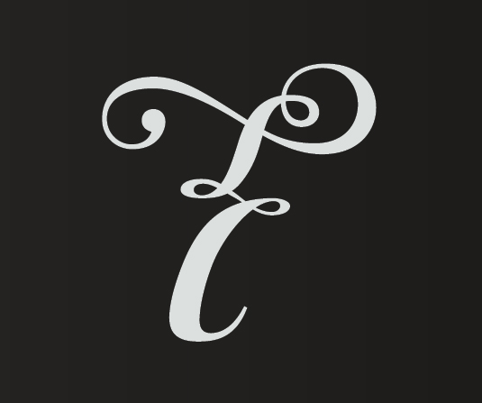A simple but evocative logo produced by Luke Prowse for Tempestra Underwear
Subtraction is a great technique for removing redundancy in any creative endeavour. It means continually asking yourself questions that begin with, "Does this logo need...", "Does this make sense?", "Does this match the brief" and "Is this self-indulgent?".
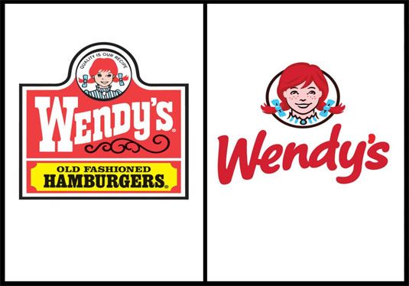Over time, most logos get simplified - Wendy's recent redesign is a prime example
If you can't rationalise an element that's part of your logo design, the chances are you need to remove it from the overall piece. When your logo is at its simplest, it's probably at its strongest.

18. Create a lock up version
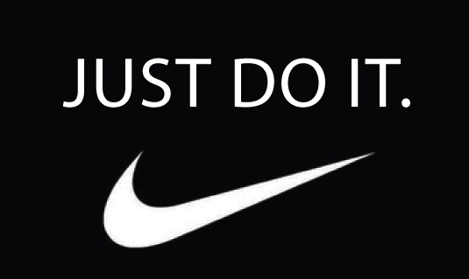Logo and slogan have to work in harmony as well as individually
A logo design often comes with a tagline (or strapline) that conveys a brand message. Nike, for example, has its swoosh device with 'Just Do It' usually seen underneath. Both elements can work separately but when they exist together this is referred to as a 'lock up'. It’s when both elements have a sense of cohesion between them.
As these elements can be seen separately the rule to remember is not to rely on the tagline to make sense of the logo or vice versa. Your logo doesn’t necessarily have to be a visual representation of the tagline but the two should be equally 'on-brand'.

19. Make your logo future-proof
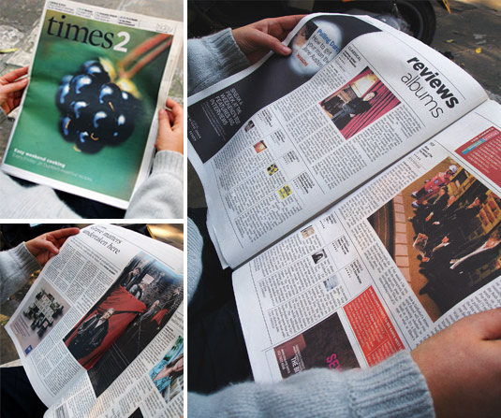Redesign and re-invigoration of the Times Newspaper supplement times2 created by Luke Prowse alongside art director Neville Brody and their in-house editorial team
Most logos are used for years, so be careful not to use ‘of the moment’ typefaces or styles that may date quickly. Don’t to be too literal either: a company selling records today might be ﬂying people to space in 25 years. Most identities such as Shell and Kellogg's have changed over time but have kept timeless brand elements whilst subtly 'refreshing' or modernising their typography. There should be elements to the logo that are enduring but be mindful that other aspects of it may need to be adapted in the future for as-yet-unknown visual formats.

20. Don't confuse 'logo' with 'brand'
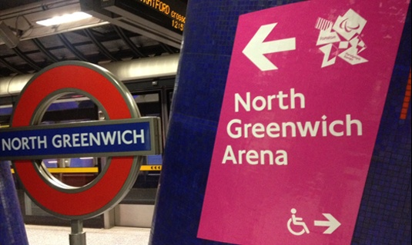Part of the 'bigger picture' for the use of the Wolff Olins 2012 Olympic Games logo device
'A logo isn't just the brand' is the most common tip to remember when creating a company's identity.
The 2012 Olympic Games logo design by Wolff Olins was universally mocked when released in 2007. Mostly this was due to media restrictions which meant they couldn't explain or show how this logo was going to be used as part of the successful London 2012 games brand and not necessarily in isolation.
If you’re presenting a logo which is mostly going to be seen 'locked up' with a strapline or connected to another visual device then show examples of this in your initial presentation.

21. Get the tone right
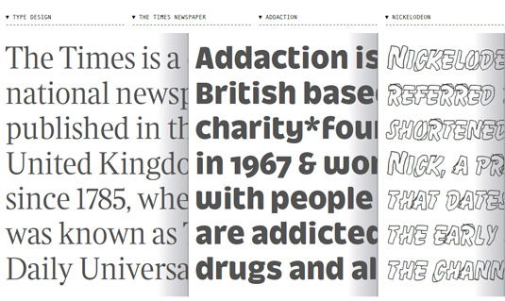An example of three type treatments by Luke Prowse - authoritative, friendly and fun
Imagine you were looking online for an accountant and come across a firm called Harewood's Accounting Services which had a logo design made up of a weedy serif font and an image of a hare sat on a plank of wood. You'd doubt whether this crowd were worth taking seriously. This fictitious company could well have multiple awards and reams of happy solvent customers, but such a logo wouldn’t inspire any trust or admiration for the services they offer.
A logo represents a business's professionalism and poor visual jokes don't work. Use fonts which sum up the 'brand mood'.

22. Show your logo design around
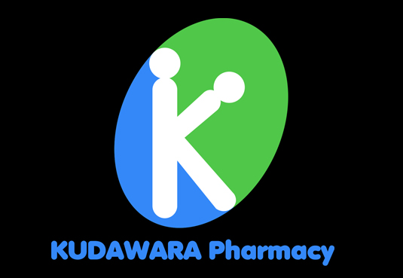Kudawara's logo was memorable for the wrong reasons
Quite a few of us will remember the Japanese pharmacy a few years ago whose logo received worldwide recognition for being unintentionally rather saucy. You of course could argue that the logo is fine and there are a lot of people in the world with dirty minds. But let's get real: how this got through final client approval is anyone's guess.
After you've completed your logo design, send it round to your mates and family for a bit of feedback. Look at it sideways, look at it upside down and reverse it. Look at it every which way you can. Then send it to the client. You wouldn't want another Kudawara on your hands would you?

23. Stick to your convictions
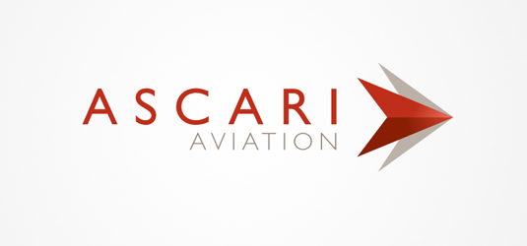Regular client feedback is crucial to avoid wasting everyone's time. Picture credit: Ben Powell at www.gogetcreative.co.uk
Sheffield-based graphic and UI designer Ben Powell suggests: "It's so important to get regular feedback from your client, but equally important that you make it clear you are the designer and that’s why you've been employed.
"As soon as a client begins suggesting things like, 'Let's make that text a bit bigger, and try this typeface', your mark becomes diluted. It's your job as the designer to make this clear from the start."

24. Fight the temptation to imitate
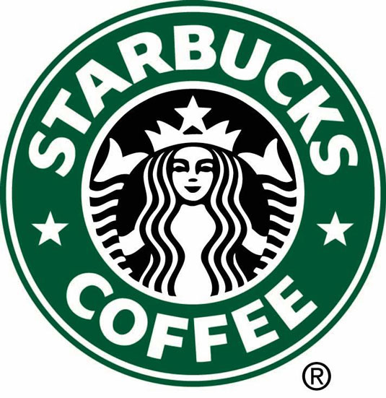Remember your logo will need to be used in a variety of different sizes and formats
We all have our design heroes and sometimes we love them so much we want to imitate their styles. Well, they do say imitation is the sincerest form of flattery. However, in the real world it's just a lazy way to solve a creative problem.
Ask yourself whether the style you're using is appropriate for the client's needs. Do they really want a logo that has the same typeface Saul Bass used for Quaker Oats in the 70s?

25. Be experimental
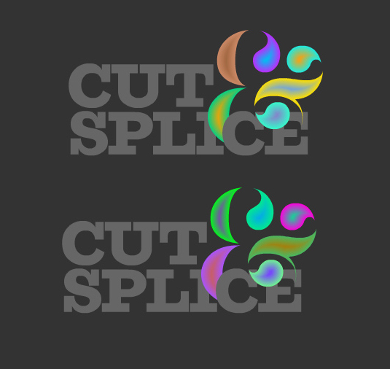Cut & Splice's logo is ever-morphing and never the same twice
Don't feel you have to be constricted by formal notions of what a logo is or does. For example, designer Luke Prowse came up with a highly original use of logo and brand identity for music event Cut & Splice, celebrating experimental composer's Karlheinz Stockhausen's Aus dem Seben Tagen.
Playing with the experimental composer's lifetime obsession with 'controlled chance', Luke created a logo design that is never the same twice, both online and digitally printed. In online form the logo continually morphs and pulsates like an ever-evolving compositional soundscape.
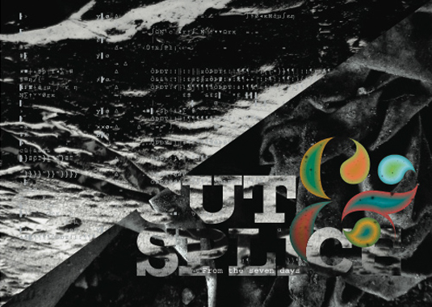Another incarnation of the experimantal Cut & Splice logo

26. Don't ask the client if they like it
When your logo is finished, try not to ask vague questions to your client such as, "Do you like it?", or, "What do you think?". You may as well ask if they like apples or oranges.
Questions you should ask include: "Does it meet the brief?" amd "Does this represent your core brand values?". If they avoid the question and just say they don't like it, ask for specifics. After all it's their brand and they should know.

27. Create a board and rip it up
You could research logos all day as there are books and websites by the score containing examples of them. Only make mood boards out of ones that share similar values. Look at your mood board and analyse what isn't successful about these logos. Then rip those boards up and use these rules as a guide for your own unique creation.

28. Create a logo style guide
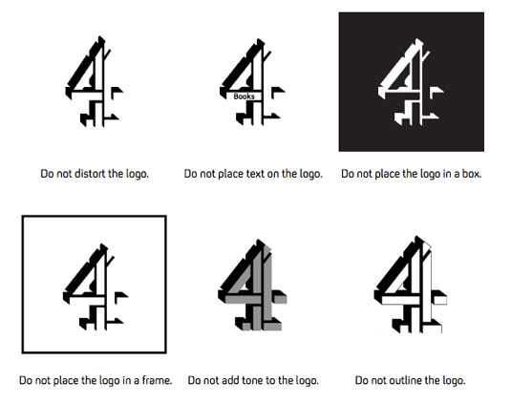The Channel 4 style guide explains in detail how its logo can and can't be used
Style guides determine the way a logo can be used and usually include colour options, size restraints, positioning, typefaces and how the logo works on different backgrounds. Check out the Channel 4 style guide for a great example of the sort of guide you should be aiming to set up.

29. What a style guide should include
A style guide should illustrate all possible colour options for a logo. It should include any Pantone colours used with a breakdown for CMYK and RGB. Other options to include are: colour and mono logos on white, colour and mono on black and colour and mono on an image background.
Some logos only work down to a certain size. This might be because they become illegible or simply lose their impact. Specify the minimum size for your logo and bear in mind how it looks on screen as this may differ from a printed version. Offer an alternative in pixels.

Positioning
The positioning of your logo may not be required in a style guide, but depending on the style and shape of your design there may be a position that you think works best. For example, text that’s ranged right might look best on the right-hand side of the page.
Give consideration to the amount of space around a logo and try to explain this without using units of measurement. For example, the space below the logo should be a quarter of its width. This ensures that whatever size the logo is used at, the correct space can be calculated easily.

No-nos
If there are any ways that your logo should not be used then make sure you specify them. The main reason for a style guide is to ensure the appearance of your logo remains consistent, so explain how the logo should not be misinterpreted and illustrate your points with examples

30. Download the logo design flowchart
Still not sure where to begin with logo design? No problem. Deliver winning logos every time by following the step-by-step processes in Johnson Banks' foolproof flowchart.

